**Heading: Calculators**

**Sub-heading: BMI Calculator**

**(Insert Calculator)**

**BMI** (Body Mass Index) is a measurement of body fat based on height and weight that applies to both men and women between the ages of 18 and 65 years.

BMI can be used to indicate if you are overweight, obese, underweight or normal. A healthy BMI score is between 20 and 25. A score below 20 indicates that you may be underweight; a value above 25 indicates that you may be overweight.

You can calculate your BMI by using our BMI Calculator below, or by using the [BMI Formula](http://www.bmi-calculator.net/bmi-formula.php).

Please remember, however, that this is only one of many possible ways to assess your weight. If you have any concerns about your weight, please discuss them with your physician, who is in a position, unlike this BMI calculator, to address your specific individual situation.

For all information on how to manage weight loss or weight gain please see our E-books and other fitness calculators here. (hyperlink to the E-books Page)

(insert BMI Chart, Below)

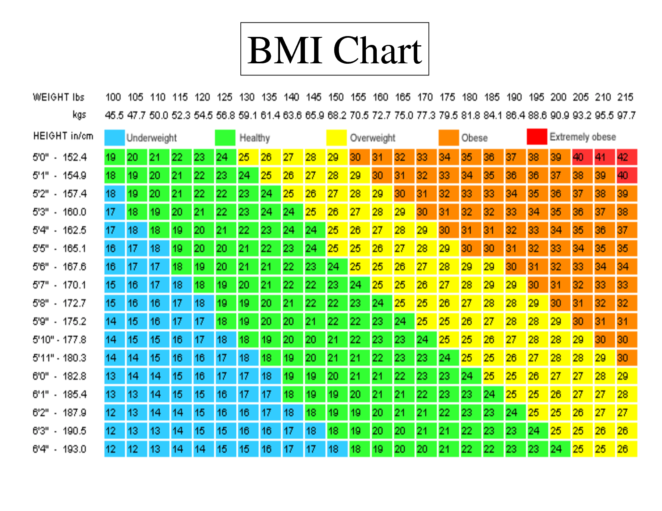

**BMI rankings**

**BMI is equal to or less than 18.5 (Underweight)**  
A lean BMI can indicate that your weight maybe too low. You should consult your physician to determine if you should gain weight, as low body mass can decrease your body's immune system, which could lead to illness.  
***BMI Underweight Treatment******please check out our E-books***

**BMI is between 18.5 and 24.9 (Normal)**  
People whose BMI is within 18.5 to 24.9 possess the ideal amount of body weight, associated with living longest, the lowest incidence of serious illness, as well as being perceived as more physically attractive than people with BMI in higher or lower ranges.

**BMI is between 25 and 29.9 (Overweight)**  
People falling in this BMI range are considered overweight and would benefit from finding healthy ways to lower their weight, such as diet and exercise. Individuals who fall in this range are at increased risk for a variety of illnesses.  
***Overweight Treatment please check out our E-books***

**BMI is over 30 (Obese)**  
Individuals with a BMI over 30 are in a physically unhealthy condition, which puts them at risk for serious illnesses such as heart disease, diabetes, high blood pressure, gall bladder disease, and some cancers. These people would benefit greatly by modifying their lifestyle.  
***Obesity Treatment please check out our E-books***

**Sub-heading: BMR Calculator**

**(Insert Calculator)**

**BMR (Basal Metabolic Rate)**

You use energy no matter what you're doing, even when sleeping. The BMR Calculator will calculate your Basal Metabolic Rate (BMR); the number of calories you'd burn if you stayed in bed all day.

If you've noticed that every year, it becomes harder to eat whatever you want and stay slim, you've also learnt that your BMR decreases as you age. Likewise, depriving yourself of food in hopes of losing weight also decreases your BMR, a foil to your intentions. However, a regular routine of cardiovascular exercise can increase your BMR, improving your health and fitness when your body's ability to burn energy gradually slows down.

Once you know your BMR, you can calculate your Daily Calories (insert hyperlink to that page) Needs based on your activity level using the Calorie Calculator.(insert hyperlink to that page)

The BMR formula uses the variables of height, weight, age and gender to calculate the Basal Metabolic Rate (BMR). This is more accurate than calculating calorie needs based on body weight alone. The only factor it omits is lean body mass and thus the ratio of muscle-to-fat a body has. Remember, leaner bodies need more calories than less leaner ones. Therefore, this equation will be very accurate in all but the very muscular (will underestimate calorie needs) and the very fat (will over-estimate calorie needs).

**English BMR Formula (Imperial)**

**Women**: BMR = 655 + (4.35 x weight in pounds) + (4.7 x height in inches) - (4.7 x age in years)

**Men**: BMR = 66 + (6.23 x weight in pounds) + (12.7 x height in inches) - (6.8 x age in years)

**Metric BMR Formula**

**Women**: BMR = 655 + (9.6 x weight in kg) + (1.8 x height in cm) - (4.7 x age in years)

**Men**: BMR = 66 + (13.7 x weight in kg) + (5 x height in cm) - (6.8 x age in years)

**Sub-heading: Body Fat Calculator**

How much Body Fat are you carrying? Find out if you are in the healthy range. This Body Fat calculator is based on a formula developed by the US Navy!

First, your body fat percentage is simply the percentage of fat your body contains. If you weigh 140 pounds and are 10% fat, it means that your body consists of 14 pounds fat and 126 pounds lean body mass (bone, muscle, organ tissue, blood etc.)

**(Insert bodyfat calculator here)**

A certain amount of fat is essential to bodily functions. Fat regulates body temperature, cushions and insulates organs and tissues and is the main form of the body's energy storage.

The following Body Fat Chart describes body fat ranges and their associated categories.

| Body Fat Percentage Categories | | |
| --- | --- | --- |
| Classification | Women (% fat) | Men (% fat) |
| Essential Fat | 10-12% | 2-4% |
| Athletes | 14-20% | 6-13% |
| Fitness | 21-24% | 14-17% |
| Acceptable | 25-31% | 18-25% |
| Obese | 32%+ | 25%+ |

Knowing your body fat percentage can also help you determine if your weight loss goals are realistic. Remember, weight loss doesn't always mean fat loss.

For example, let's say you are a 130 pound woman with 23% body fat, and your goal is to lose 20 pounds.

|  |  |
| --- | --- |
| Initial body fat | 130 pounds x 0.23 body fat = 30 pounds body fat |
| Lean body mass | 130 pounds total - 30 pounds fat = 100 pounds lean body mass (bones, organs, ...) |
| Goal | 130 pounds - 20 pounds = 110 pounds |

As you can see, the goal of losing 20 pounds is not realistic or healthy. At 110 pounds, this woman still requires 100 pounds of lean body mass, but would only be carrying 10 pounds, or only 9% body fat. From the body fat chart above, you can see that this is a dangerously low percentage.

A better goal might be for the woman to reduce her body fat from 23% to 18%. In this case:

130 pounds x 0.18 = 23 pounds body fat

100 pounds lean body mass + 23 pounds body fat = 123 pounds goal weight.

So, for this individual to achieve a lean, but healthy 18% fat, she would need to lose only 7 pounds of fat, reducing her weight from her current 130 pounds to 123 pounds. Losing more than 7 pounds means losing lean body mass (usually metabolically-active muscle tissue), which is clearly not desirable.

So before you decide that you need to "lose weight", remember to consider that "weight" consists of both lean body mass and body fat. Try to keep your weight loss goals realistic, and remember, keep the calorie-burning muscle, and lose only the fat.

**Sub-heading: Ideal Weight Calculator**

The subject of Ideal Body Weight (IBW) has remained a hot topic issue for decades. The subject is so critical because it touches on every aspect of human health and treatment. In particular, a doctor has to know your IBW to calculate the appropriate dosage. Besides, more people have become aware of health and fitness and want to have facts about their bodies, effectiveness of fitness training and efforts towards good health.

**(Insert Calculator here)**

**Sub-heading: Weight Loss Calculator**

This weight loss calculator allows you to calculate the number of calories you should eat in a day to reach a specific target weight by a certain date.

**(insert Calculator here)**

**Sub-heading: Calorie calculator**

**I would like something similar to the below website including the website capture where I can automatically email them the results if possible?**

**https://www.iifym.com/iifym-calculator/**